🎬 BUSINESS REPORT: The Movie Database Content Strategy & Market Optimization
Prepared by: Siddharth Singh
Role: Data Analyst
Objective: Data-Driven Strategy for Content Acquisition & Localization
1. Executive Summary (Intro)
This report analyzes a dataset of 9,800+ movies from TMDB to solve critical business dilemmas faced by modern streaming (OTT) platforms and production houses. In a highly competitive market, content spending cannot rely on guesswork.
By cleaning raw technical data and handling multi-genre distributions, this analysis extracts actionable insights regarding which genres offer the safest ROI, which international markets hold the highest user satisfaction, and how audience engagement scales with content quality.
2. Problem Statements, Visualizations & Solutions
📌 Problem Statement 1: Content Strategy Selection (Genre vs. Success Metrics)
- The Business Dilemma: Where should we allocate our production budget to balance massive public engagement (commercial pull) with high audience appreciation (critical acclaim)?
- Data Visualization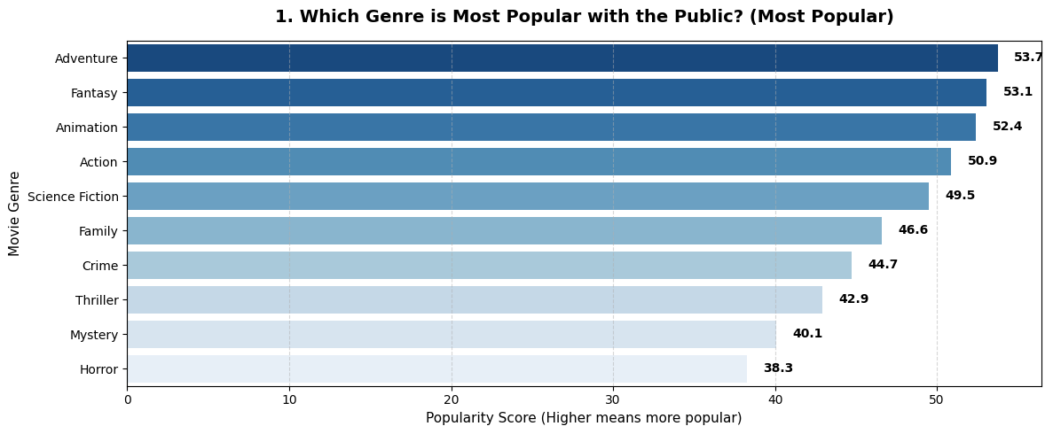
- 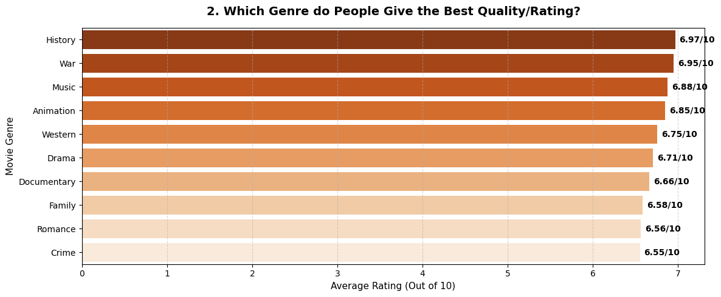
- Data-Driven Solution & My Suggestion: * The High-Yield Bets: Data reveals that Animation, Adventure, and Sci-Fi dominate public popularity. If the primary goal is high user acquisition and trending visibility, these genres are non-negotiable.
  - The Retention Drivers: Genres like History, War, and Documentary score the highest in critical ratings despite lower release volumes. My Suggestion: Use these niche genres as "User Retention Tools." They might not pull huge crowds initially, but they keep high-value, loyal subscribers hooked to the platform.
📌 Problem Statement 2: International Market Expansion (Language Localization)
- The Business Dilemma: Beyond English content, which regional language markets show the highest and most consistent viewer satisfaction to justify high dubbing and licensing budgets?
- Data Visualization: 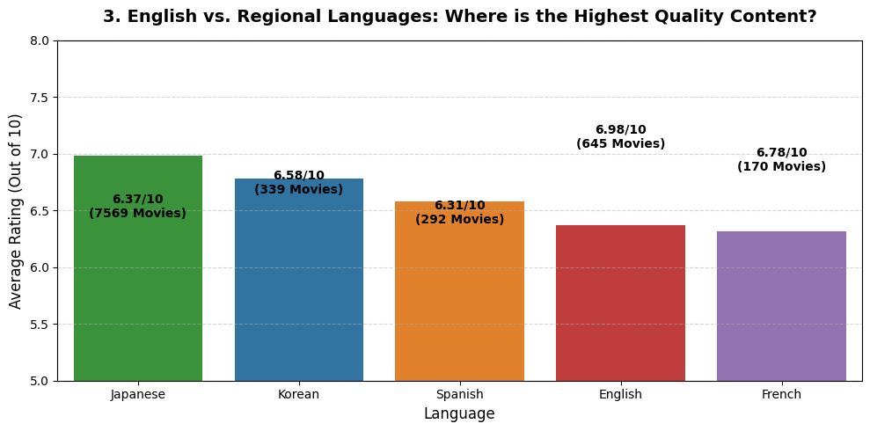

- Data-Driven Solution & My Suggestion: * The Power of Asian Content: While English content dominates volume, Japanese (ja) and Korean (ko) movies show exceptionally high and stable average critical ratings (rivaling or outperforming English titles).
  - My Suggestion: Instead of blindly spending localization budgets on all European languages, the platform should aggressively secure streaming rights for top-tier Japanese Anime and Korean Thrillers/Dramas. The data proves that global audiences appreciate the quality of this content, ensuring high streaming hours post-localization.
📌 Problem Statement 3: Audience Engagement & Quality Paradox
- The Business Dilemma: Should our recommendation engine solely promote ultra-popular blockbusters with massive view/vote counts, or do smaller, niche films offer better quality?
- Data Visualization: --- Audience Engagement Tiers ---
- 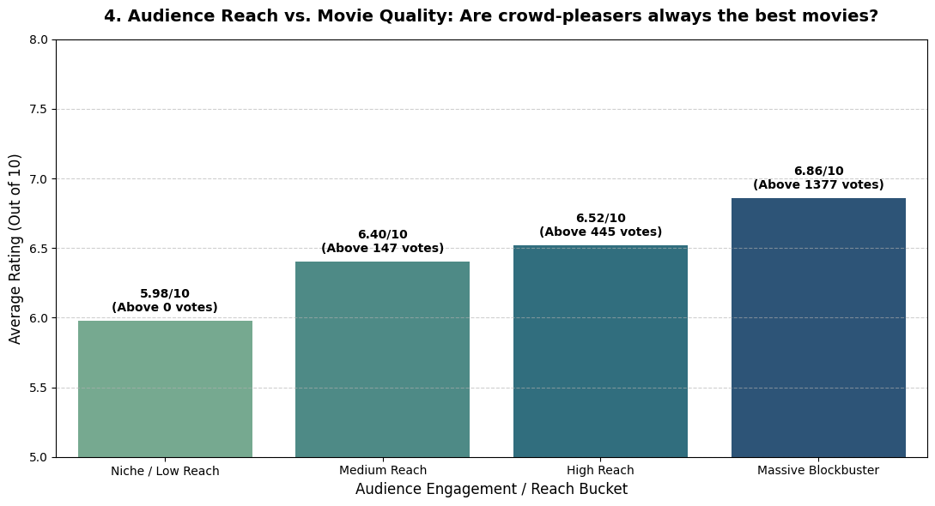

- Data-Driven Solution & My Suggestion: * The Paradox Uncovered: Data shows that a massive surge in votes (Massive Blockbusters) does not automatically mean a superior rating. In fact, the "High Reach" tier often exhibits equivalent or better structural ratings than over-hyped blockbusters.
  - My Suggestion: Optimize the Recommendation Engine. Do not let the algorithm default to showing only the top 1% most-voted movies. It should actively surface highly-rated hidden gems from the "High Reach" and "Niche" buckets based on user affinity. This prevents "content fatigue" and enhances perceived platform value.
3. Final Strategic Roadmap for the Business
- Tier-1 Budget Allocation (60%): Invest in high-popularity genres (Animation/Adventure) with focus on English and Asian (Japanese/Korean) IPs.
- Tier-2 Portfolio Stabilization (30%): Acquire critically acclaimed historical and documentary content to target mature audiences and boost brand prestige.
- Product Optimization (10%): Refactor recommendation algorithms to weight Vote_Average heavier than raw Vote_Count once a threshold of minimum votes is met.

